UPCOMING EPC EVENTS
Do you plan to attend any of the forthcoming EPC events as:
Op-Ex Russia & CIS 2018
14-16 November 2018, Sochi, Russia
□ Delegate □ Speaker □ Exhibitor □ Sponsor
Bahrain Week 2018, incorporating BBTC-MENA & ME-CAT
5-6 December 2018, Manama, Bahrain
□ Delegate □ Speaker □ Exhibitor □ Sponsor
IOSF 2019 & IMO 2020
15-17 January 2019, London, United Kingdom
□ Delegate □ Speaker □ Exhibitor □ Sponsor
ME-TECH 2019
26-28 February 2019, Abu Dhabi, UAE
□ Delegate □ Speaker □ Exhibitor □ Sponsor
IDW 2019, incorporating IDTC & BBTC
27-30 May 2019, Sardinia, Italy
□ Delegate □ Speaker □ Exhibitor □ Sponsor
ADW 2019, incorporating ASIA-TECH & ASIA-BBTC
8-10 October 2019, Bali, Indonesia
□ Delegate □ Speaker □ Exhibitor □ Sponsor
Thank you for filling in this form. Please give this form to the EPC team to be entered in a prize draw at the end of the event. You will have the chance to win a Samsung Tablet.
Your name:
_____________________________________________________________________
Company name:
_____________________________________________________________________
Тhank you for attending BBTC 2018!
We look forward to welcoming you at our future events!
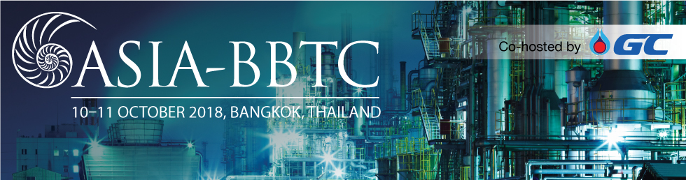
evaluation form
At Euro Petroleum Consultants we are constantly aiming to improve our events. We would highly appreciate your feedback and recommendations. In gratitude, we organise a prize draw at the end of the event. Please hand in the filled form to our hostesses or at the registration desk for a chance to win a Samsung Tablet.

Please rate your overall experience:
 | 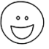 | 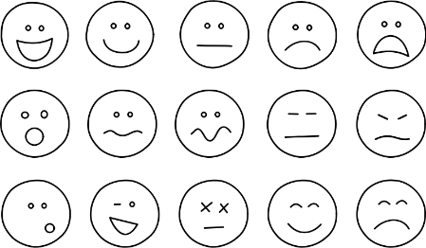 | 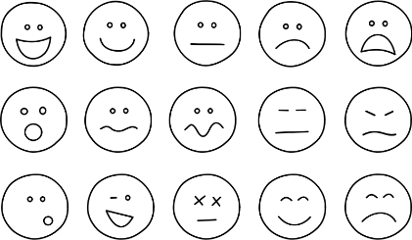 |  | 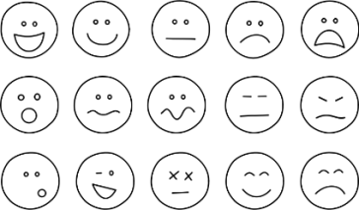
Programme content & relevance
Technical & strategic insight gained
Exhibition organisation & activities
Relevance & quality of attendees
Networking opportunities
Value for money
OVERALL EVENT EXPERIENCE

Your suggestions on conference quality improvement -
what would make the above a :
_____________________________________________________________________________________________________________________________________________________________________________________________________________________
_______________________________________________________________________

ABOUT THE EVENT
What did you like most about the conference?
______________________________________________________________________
What did you like least about the conference?
______________________________________________________________________
Which topics did you find most interesting?
______________________________________________________________________
Which topics did you find least interesting?
______________________________________________________________________
Which Speaker (-s) would you rate as most interesting?
______________________________________________________________________
Which Speaker (-s)'s presentation did you find least informative?
______________________________________________________________________
Which other topics and issues would you like to discuss at the next conference?
______________________________________________________________________
______________________________________________________________________
______________________________________________________________________
_____________________________________________________________________
OVERALL IMPRESSION AND COMMENTS:
_____________________________________________________________________
_____________________________________________________________________
_____________________________________________________________________
_____________________________________________________________________
_____________________________________________________________________
_____________________________________________________________________

ABOUT YOURSELF
How did you find out about this event?
_____________________________________________________________________
Which professional magazines / online media do you read?
_____________________________________________________________________
Would you prefer to attend:
□ a week of back to back events
□ a single event with parallel sessions
Why?________________________________________________________________________________________________________________________________________
How likely are you to recommend this event?
□ I would recommend it □ Neutral □ I would not recommend it
Do you have a colleague who would be interested in future events?
Could you provide their contact information below (name, e-mail, etc.)?

_____________________________________________________________________

Leave us a testimonial
We would appreciate if you could provide a testimonial of your experience at this event. We might publish it on our website www.europetro.com with your company name and position.

_____________________________________________________________________
_____________________________________________________________________
_____________________________________________________________________
_____________________________________________________________________
_____________________________________________________________________

